Air Force Academy's Class of '22 gets ‘Recognized'
By Jennifer Spradlin, U.S. Air Force Academy Public Affairs / Published March 15, 2019
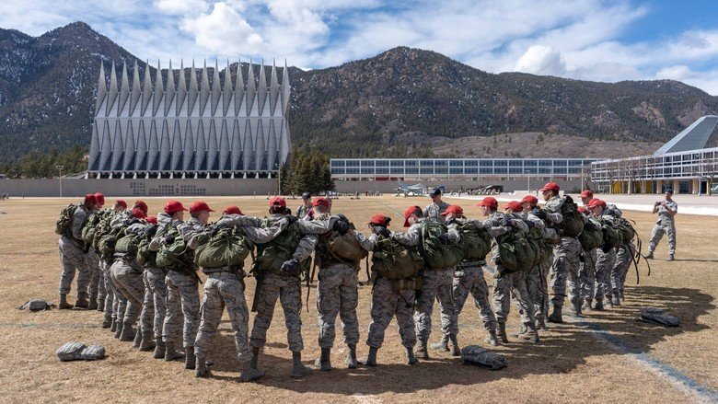
Freshmen cadets team up before taking on another challenge during Recognition at the U.S. Air Force Academy, March 7-9. Recognition is a military training assessment that measure how well the fourth-year cadets have performed as individuals and team members since arriving for Basic Cadet Training in June. (U.S. Air Force photo/Cadet 1st Class Emily Graves)

U.S. AIR FORCE ACADEMY, Colo. -- The Class of 2022 marked their formal induction into the Cadet Wing March 9 after taking on the rigors of Recognition.
Recognition is an intensive military training assessment that includes a variety of physical, mental and emotional challenges to measure how well the cadets have performed as individuals and team members since arriving for Basic Cadet Training at the Academy in June.
“Recognition is not something you are given, it’s something that is earned, and that’s really special because it means they have worked hard for it,” said Cadet 1st Class Madison Froebe, cadet officer-in-charge of Recognition.
Froebe said the event mimics the high-stress service environment cadets will face as future Air Force officers while developing resiliency and agility. Recognition is also a leadership test for the upper three classes, which builds confidence in their ability to manage a complex training event.
“I have seen through my experience as an [air officer commanding] how the event brings the squadron even closer together in common cause, and there is a huge sense of pride for the fourth degrees that they were able to make it through Recognition,” said Lt. Col. Dewese, director of cadet operations.
The annual training event connects the fourth class cadets to their upperclassman and generations of other Academy alumni. “It’s a monumental event that stands out long after they graduate,” Dewese said. “From Brig. Gen. Kristin Goodwin, commandant of cadets, to Gen. David Goldfein, chief of staff of the Air Force, it’s a common thread they all share in the Long Blue Line.”
Cadet 4th Class Molly Ellinger said Recognition helped her understand the concept of selfless service while increasing her pride in serving alongside the members in her squadron.
“Being here at Academy is one of the most unique experiences in the world, and it’s not something I think you can truly prepare yourself for,” she said. “[At] in-processing [for BCT], I knew I was going into the military, but I didn’t really understand what that meant. It’s been that camaraderie, the understanding that you grow with the people around you that made it so special for me.”

